Copies of current and past newsletters can be found at: http://www.asset-management-solutions.com/newsletters.htm
Newsletter for October 2006
I appreciate receiving your comments on this newsletter and any suggestions for future topics. If there is someone you know who would be interested in receiving this newsletter, please feel free to forward the newsletters to them, or forward their e-mail address to me and I will include them in the distribution of future newsletters. If you wish to remove your name from distribution of this newsletter, please respond via e-mail. Please see “Contact Us” at bottom for e-mail address for feedback, comments and removal from distribution.
This month’s newsletter is by Ben Stevens of OMDEC. Ben mentioned this one is longer than is typical and he offered to divide it into two articles, but I think it makes more sense to read it at one sitting, rather than waiting for the second part two months later. So this time you should put the kettle or coffee pot on and make some time in your day to read through it. To reinforce Ben’s last paragraph, I find it surprising how many organizations have not put even estimated an order of magnitude cost against their cost of downtime. Ben Stevens can be reached at ben@omdec.com .
On another note, I am still looking for more feedback on some of the issues you face with managing maintenance in the current tight skilled labour situation and how you are coping (or not coping) in that environment.
To keep this newsletter relatively short, this is intended to be a broad overview of issues for physical asset management, rather than a comprehensive discussion of the topic. Please bear in mind that “relatively short” is a relative term particularly given the potential depth of this subject!!

Improving PAM Risk Analysis Using a CMMS/EAM

Introduction
CMMS/EAM systems have been around for well over 25 years now. Their level of adoption around the world varies from saturation (in North America) to almost total absence (Japan). And within each region or country, the extent of the value that the users derive from the systems varies from “almost nil” to “not bad”. Only very rarely do users claim that these highly sophisticated and expensive tools provide the outstanding value that they are capable of. As an interesting indicator, a US power generation company is currently in the middle of a program to raise their usage from 30% of the systems capability to 50% - and they are widely recognized as the leaders in this field.

First a Little History
So what are CMMS’s and EAM’s all about? CMMS – (Computerized Maintenance Management Systems) and EAM’s (Enterprise Asset Management systems) seem to suggest from their name that they are all about managing maintenance and assets. A fundamental basis of maintenance and asset management is measuring and extending the life and the reliability of the equipment. If they are not doing that, then what are they doing? The following slide – taken from (too many!) years of working with CMMS’s –suggests the stages of evolution that users typically go through as their experience grows.
We see users going through up to five phases – each with a clear set of dominating usage and characteristics. The figures at the foot of the slide show our guesstimate of the % of users in each class. What is disturbing about this slide is that users clearly need to be in Phase 4 of the CMMS evolution – (ie on the extreme right hand side of the slide) in order to derive real benefit in terms of equipment life and reliability. Yet only about 5% of users fall into this category. The remaining 95% are using the administrative features of CMMS to prepare work orders and materials requisitions faster, to improve work flow and streamline activities and to prepare lots of reports that typically don’t answer the right questions. And frequently that is because there is rarely a common language between senior executives and maintenance managers. What is not happening is the use of the tool to extend equipment life and improve reliability.
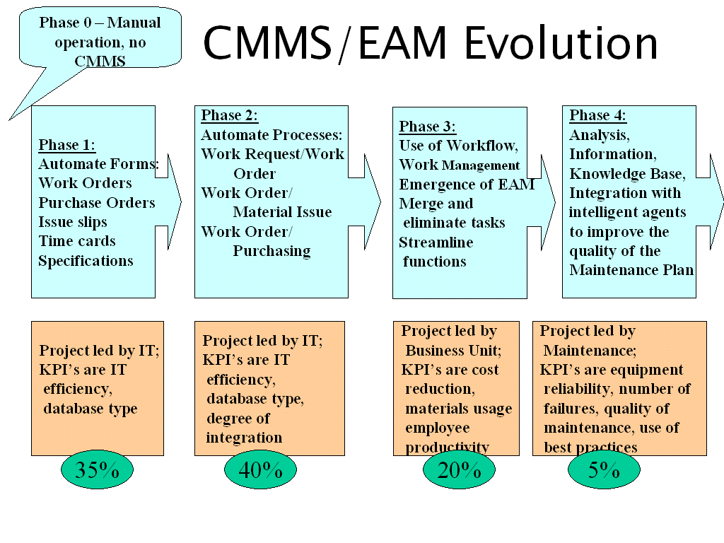
Figure 1: CMMS/EAM Phases of Evolution
Why is this? The problem is that to proceed to Phase 4 requires the user to turn the masses of data from the CMMS, into consistent, accurate integrated information. And then integrate the equally massive amounts of data from CBM and from RCM. In practice that is very difficult; the developers of these tools seem to see themselves as in competition with the others -- that recognizing the capability of the other tools will undermine their market position, that integration with other tools reduces their claim to be THE solution.
Having said this, then what is the solution? The solution lies in understanding the strengths and weaknesses of each discipline, and building a knowledge base that includes the key elements of all three. Then you must add in your own growing experience so that the resulting knowledge base becomes unique to your company and thus best able to serve the needs of your company.

What is Reliability? What is Failure?
Reliability in recent years has become almost synonymous with RCM; this is a tribute more to good marketing than to accuracy. RCM (Reliability Centred Maintenance) is an excellent tool. However, RCM is only one tool in the Maintenance Specialists tool-kit - it becomes more effective when combined with other tools – and in turn makes those other tools more effective.
One important thing that RCM has helped us with is the concept of failure; in fact it has helped with two important definitions of failure – functional failure and potential failure. Functional failure occurs when the equipment no longer is able to perform the function that is required of it by the user. Thus a cooling pump that must pump 1000 litres per minute has “failed” if it only pumps 999 litres a minute – that is, something downstream will overheat. Potential failure occurs when a condition exists that, if uncorrected, will lead to failure at some predictable later date; thus hopefully giving us time to prevent it.
This is the “technical” view of failure, and is important for us in our discussion. Beyond RCM, there is a growing number of analytical techniques that help us to better understand the issue of reliability – these include Failure Analysis, Root Cause Analysis, Weibull analysis and so on. All are valuable, but all share one flaw in common – that is they focus solely on the technical aspect of failure.
But let’s now look at another view of failure – through the eyes of the CEO or CFO of the organization. From their viewpoint, a failure is anything which:
- reduces revenue
- reduces profit
- reduces the level of public image
- reduces customer satisfaction
Ideally this CXO-level view and the technical view of the issue should be the same – but of course they never are. Both are important, but how do we combine the data behind the two views into a single agreed position?

Reliability and Failure in the CMMS
CMMS users have typically used their system for reliability information such as:
- MTBF (Mean Time Between Failures)
- MTTR (Mean Time To Repair)
- MTTF (Mean Time To Failure)
- Number of Repeat Failures …. And so on.
This is good as far as it goes, but again what is missing is the information that links this to the CXO-level management. For this we need to add in the critical ROI and cost data. Here we need to create a report from the CMMS that records not only the frequency of failure but also the cost of that failure. This allows us to focus on those equipments or systems that cause the greatest disruption to the company’s profitability.
To look at the cost of failure, we need to consider three different elements:
- the cost of repair – not only the standard labour and materials, but expediting costs, overtime costs, damage to related equipment and so on.
- the cost of production losses and therefore revenue losses for the duration of the outage. Notice that we are costing the lost revenue; therefore any slowdown in production rate counts as a failure.
- the costs of penalties for a safety violation, or an environmental spill, the loss of public image through non-supply of services or products, the cost of a loss of a contract, public embarrassment etc. These costs are increasingly significant, and often overwhelm the other cost categories. However they are very subjective and are typically left out of the equation.
Figure 2: The Costs of Failure
To record, and to emphasize, the true impact of the loss of reliability, a regular report should be created by your CMMS – similar to the following:
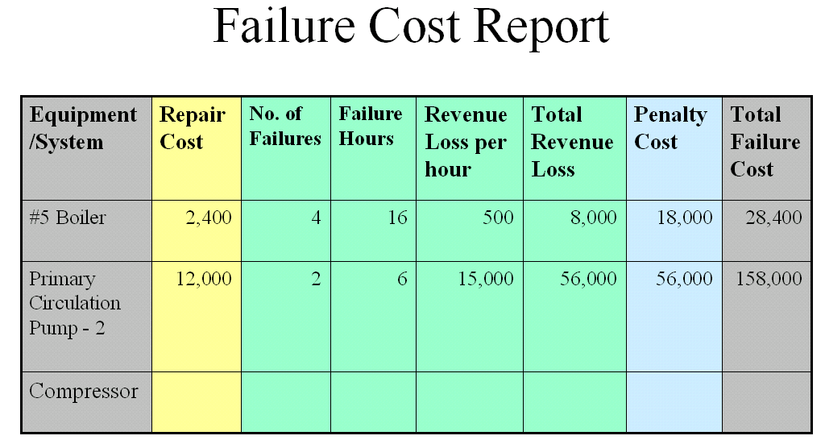
Figure 3: Failure Cost Report
This simple example shows that although the #5 Boiler failed 4 times for a total of 16 hours, the problems caused by the pump failures were significantly more expensive and therefore should draw a much higher degree of attention and priority.
Now, no CMMS that I have ever seen has a standard report that looks like this. However, with a bit of creativity and some help from a report writer, there is no reason why this should not be a standard report – all the data is there – or if not can easily be made available. We will come back to the data sources at the end.

The Importance of Risk
This kind of report will do much to convince the CXO-level managers that the Maintenance department really does focus on the right issues. But a second and equally important issue that commands huge attention from the CXO-level is that of risk – for example what is the risk of a failure before the customer gets his promised delivery? What is the risk that this quarter’s ROI will be compromised?
To illustrate this, I’d like to draw on a recent off-shore project. Power demand is running close to the country’s ability to supply. Fear of public annoyance at brown-outs or blackouts pushes the generation company to delay scheduled maintenance. Delayed maintenance risks damage which may not be disclosed until the delayed shutdown occurs. Parts (of course) are not available to remedy the unexpected damage - which delays restart, which reduces generation capacity which causes the Genco to delay more scheduled maintenance. And so it goes on.
In the long term, the solution has to be a higher power supply combined perhaps with greater production efficiency and energy savings. But with demand growth in the 15% range per year, playing catch-up will continue to be a very difficult challenge. One continued request from management has been to develop a means of introducing risk into the equation – trying to quantify the probability and impact of failure from continued operation (the Run Risk) against the PM Risk – the impact of a preventive shutdown. This core information can then be used to compare the impact and risk of shutting down two equipments.
We have already defined the failure costs; so let’s now also define the PM costs alongside the failure costs for comparison:
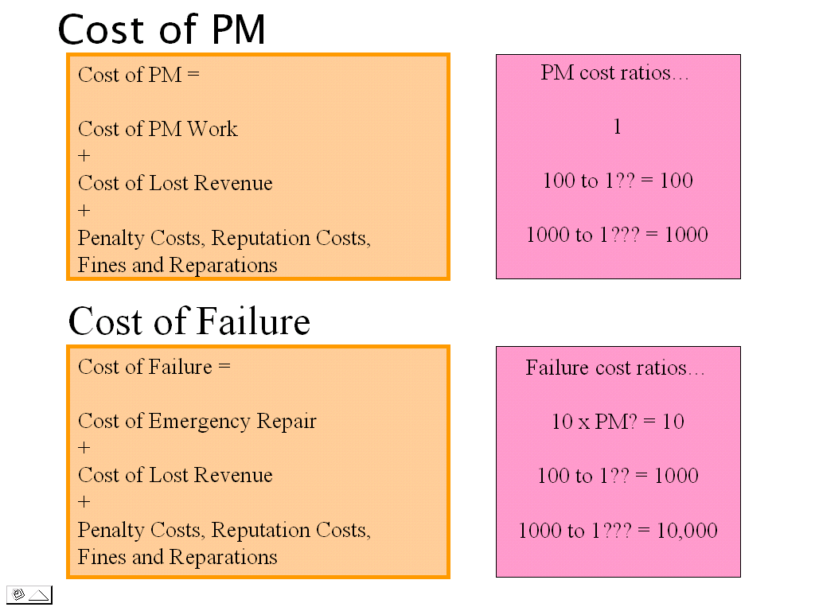
Figure 4: Costs of PM versus Cost of Failure
This gives us the basis for a cost comparison which we will use later. But first we have to understand risk and how to quantify risk:
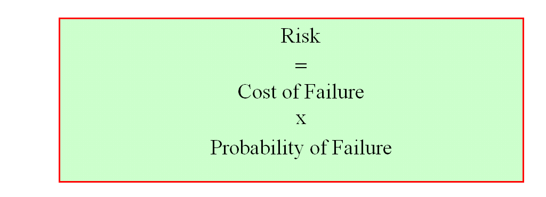
Figure 5: Definition of Risk
So let’s use an example to introduce real numbers:
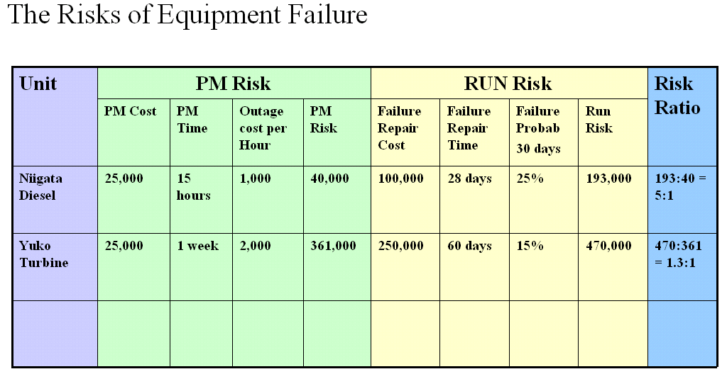
Figure 6: The Risks of Equipment Failure
Here we show the PM Risk for the diesel as being $40,000, versus $361,000 for the turbine, while the Run Risks are $193,000 and $470,000 respectively. Before we ask which strategy we should employ, let’s define them and look at how the calculations were done. The PM Risk is the risk of doing a preventive replacement to prevent a failure – remembering the three type of costs, and remembering that Risk = Cost x Probability. Similarly the Run Risk is the risk of failure if we run the equipment without doing the preventive replacement. So the calculations are:
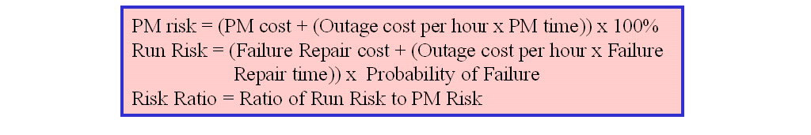
Figure 7: Risk Calculations
Next let’s look at the probability in both calculations – the probability of a PM if we decide do it, is clearly 100%. But the probability of failure is some number lower (we hope!). But if we are looking at the probability of failure, then we need to define a time frame. In this case we have set the timeframe at 30 days, but it could equally well be 60 days, the end of the production run, or – more likely –the next scheduled outage. We’ll look at this again later.
Clearly the Run Risk and the PM Risk for the Diesel are considerable lower than the Turbine. Looking at the implications for the company’s ROI requires more data that we have available, but we can use the Risk Ratio as an approximation. We can define the Risk Ratio as the ration between risking running the equipment rather than interrupting production for a PM task – i.e. Run Risk : PM Risk.
Looking at it in another way, we can invest $40k to do a PM on the diesel in order to avert $193k of risk by continuing to run; for the turbine, we have to invest $361k in a PM to avert $470k risk by continuing to run. The Diesel’s 5:1 Risk Ratio makes it more attractive target than the Turbine’s 1.3:1.

The Impact of Time on Risk
The next step we should take is to recognize that this example shows the situation at a single point in time – based on the probability of failure within 30 days. Does the picture change if we look forward 60 or 90 days?
For this view, we can prepare a graph that looks something like the following:
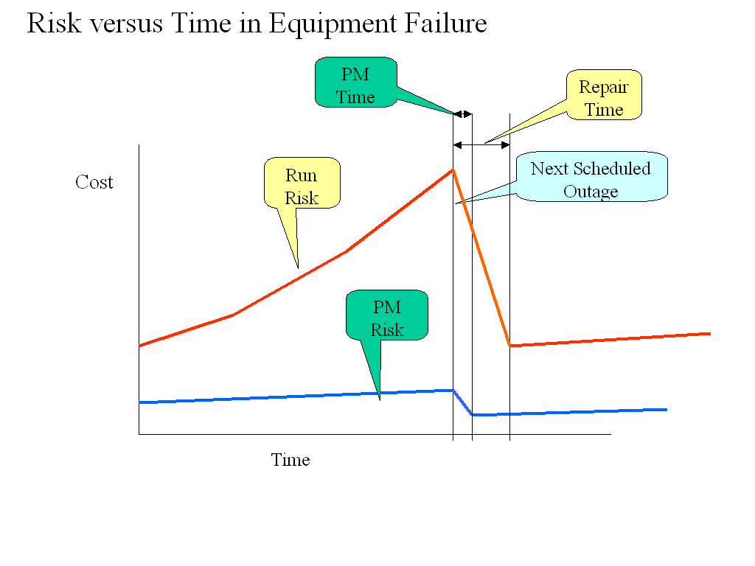
Figure 8: Risk versus Time in Equipment Failure
Here we track the Cost (=Risk as defined in the earlier formulae) on the vertical axis. In this example we have assumed for simplicity that in both cases the next scheduled outage co-incides (ie the PM outage and the expected failure outage). This allows us to show that the repair time for the PM is much shorter than the repair time for the failure. The Repair Risk will stay relatively constant as the cost of the preventive repair plus the outage losses for the duration of the repair will only vary slightly and the probability is constant at 100%. By contrast the Run Risk will escalate quickly as the probability of failure rises beyond the 30 days shown in the previous table. After the scheduled outage, the risks will clearly be much lower, but will re-assume their upward trend as the probability of failure again starts to increase.
Clearly this graph starts to get very busy if we then add a second and third piece of equipment. So to concentrate on the core principle of improving decision-making, we will track only the Risk Ratios.
In the following graph we can see that the company has set the maximum level of risk at a Risk Ratio of 6 – this is very subjective and will vary with the company and its market place. We can also see that for EQ1 the rise in the predicted Risk Ratio crosses the company’s risk maximum in early January, but this will occur before the next scheduled shutdown. This gives us a good warning period for action but clearly advises management that their risk maximum is violated before the shutdown occurs.

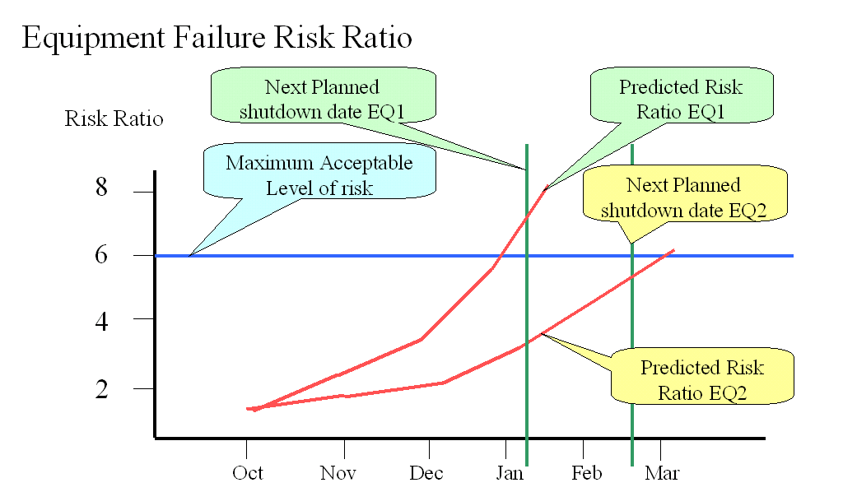
Figure 9: Equipment Failure Risk Ratio
On the other hand, EQ2’s next planned outage occurs in February – before the risk maximum is exceeded.
This shows the status as of October; but as time passes, the probabilities of failure will change based on the analysis of the equipment condition. The graph can then be updated to show the changes in the risk levels.
Before we move on to examining the practicalities of creating these graphs, let’s take a look at the advantages of creating this sort of information. Remember that deferred shutdowns and their impact on the reliability of future production and customer deliveries is the real issue.
So let’s also look behind the scenes and ask the question why do we not shut down when the maintenance community requests it? The answer is that the known fact of customer reaction overwhelms the unknown cost and probability of failure. In the absence of hard maintenance risk data, the decision is to continue in production and “risk it”.
Obviously we have no difficulty if the social, political or business decision to continue production and risk a more extended shutdown as a result of a failure is based on good quality knowledge. What we are adding to the equation is a relatively objective maintenance view of the balance of risk – and expressed in terms that the business decision-makers can clearly understand. This greatly strengthens the knowledge base and helps to improve the decision-making.

Data Sources
The question we must now address is whether this is science fiction or industrial fact. We can do that by examining the sources of data, how it can be collected and what is the process involved in creating this valuable information.
Let’s go back to Figure 3: The Failure Cost Report. Clearly the selection of the equipment to be measured will come from the CMMS equipment hierarchy. As with the CMMS data, we can look at individual equipments, systems or groups of equipments, or components.
The key question is at what level is the work order data collected and stored – most systems these days allow for all three levels. In large plants, working at the component or equipment level involves too much data, so the system level is the important one. But for problem areas, then move down to the equipment or component level. Most of the data sources are quite straightforward, but the following need some comment:
- Number of failures and the failure hours. One underlying assumption is the definition of failure and therefore the duration of the failure; as noted earlier, anything that reduces the company’s output is a failure. However a slowdown may still produce output; hence we need to adjust the failure hours to compensate – for example a 2 hour slowdown to 50% output = 1 failure hour.
- Revenue loss per hour – this is a calculation based on throughput, market conditions etc and should be revisited periodically. It can be stored in a spare CMMS field.
- Penalty cost – as noted earlier, many companies understand the issue, but do not attempt to calculate it. However it is important to recognize it as it is typically the biggest factor in the risk equation. A consensus figure should be included, should be updated periodically and can be stored in a spare CMMS field.
- The Total Revenue Loss and the Total Cost of Failure are calculated from data in the table.
Thus we can see that the information we derive from this table about the real costs of failure are based on solid work order data supported by some fairly simple assumptions. It is readily available.
Let’s now turn to Figure 6: Risks of Equipment Failure. Here the rules of the game have changed a little. When we start to examine the risk of failure and try to assign probabilities to it, then the data aggregations from the previous calculations are no longer adequate. The reason for this is that we must now look at the individual failures of equipments or systems to predict failure.
Most CMMS’s these days provide for a Fault Code to be entered in the work order to identify the “reason” for failure. Notice the “quotation marks” around the “reason” for failure. The drop down lists of fault codes are typically many dozens of items long and usually bear no relation to the equipment being maintained. This in turn leads to most of the records showing the first item in the list as the “reason” – closely followed by “Other”. Clearly this is not the best data to build an analysis on.
What we should be doing here is to use the Failure Mode from the RCM analysis instead of the fault code. Using a tool such as REWOP (Reliability Engineering Workbench Optimizer) to provide a hot link between the CMMS and the RCM database not only allows for the failure mode to be accessed, but also allows the RCM database to be updated with your new maintenance experience. And of course if you do not have an RCM database, it provides a simple way to start.
So in Figure 6, we need to focus on these potential failures (PF’s) and functional failures (FF’s) that are due to occur in the next 30 days. The definition of the PF and FF come from the RCM world, but for the probability of failure, we need to turn to a tool such as EXAKT. EXAKT uses statistical analysis to link historical records of the equipment’s condition to past failures plus key event data. This allows it to show the probability of failure over the next period for each of the key PF’s and FF’s. One element of information typically missing from the work order are the “events” that are key to the continued analysis of the life of an equipment – such as a temporary suspension from service. These need to be carefully tracked to maintain continuity of the unit’s history – again REWOP can solve this problem for us.
The final pieces of the puzzle we require to complete the model are the next scheduled shutdown (typically available from the CMMS) and the Maximum Acceptable Risk Level shown in Figure 9. This latter will need to be developed and refined by each company. Some industries are very risk averse – nuclear power stations and airlines for example; they will set the Maximum Acceptable Risk Level very low. Others have a higher tolerance for risk.

Who Cares?
Finally we should address the question of what type of company will find it useful to undertake this type of analysis. The answer of course lies in the concept that has been central to this paper – namely the cost of failure.
If the cost of failure is high, then the payback will be similarly high.
If the cost of failure is unknown, then maybe we should start asking some questions….

Upcoming
Please advise me, if there are other topics on maintenance management, project management, or physical asset management issues that would you would find of interest. As requested, there will be one or more newsletters on CMMS system introduction, selection, and implementation.

Dr. Andrew Jardine is again hosting the IMEC (International Maintenance Excellence Conference) at the University of Toronto, and is scheduled for November 1 to 3, 2006. Additional information can be found at www.imec.ca . Ben Stevens will be providing the keynote presentation on the subject of this month’s newsletter.

PEMAC (Plant Engineering and Maintenance Association of Canada) is again organizing their MainTrain conference for November 28 to 29, 2006 including pre-conference (November 27) and post-conference (November 30) seminar and course. For more information on the conference, see the MainTrain web site: http://maintrain.ca/. For more information on PEMAC, please check their web site at: www.pemac.org.

Contact Us
To provide feedback on this newsletter, including comments on past articles, ideas for future articles, or to remove your name from distribution of this newsletter, please e-mail me at len@asset-management-solutions.com.
Please feel free to contact us to discuss any of your physical asset management requirements. For more information on how we can help you, please contact me directly. See our web site at: http://www.asset-management-solutions.com for other information on Asset Management Solutions, including asset management issues and solutions.
Copyright 2003 - 2006 © Leonard G. Middleton – Asset Management Solutions

