Copies of current and past newsletters can be found at: http://www.asset-management-solutions.com/newsletters.htm
Newsletter for March 2009
I appreciate receiving your comments on this newsletter and any suggestions for future topics. If there is someone you know who would be interested in receiving this newsletter, please feel free to forward the newsletters to them, or forward their e-mail address to me and I will include them in the distribution of future newsletters. If you wish to remove your name from distribution of this newsletter, please respond via e-mail. Please see “Contact Us” at bottom for e-mail address for feedback, comments and removal from distribution.
To keep this newsletter relatively short, this is intended to be a broad overview of issues for physical asset management, rather than a comprehensive discussion of the topic.

A Standard for Asset Management

BSI PAS 55
BSI PAS 55 was developed by the Institute of Asset Management (see: www.theIAM.org) in the UK. BSI is the British Standards Institute and PAS stands for “Publicly Available Specification”. IAM (Institute of Asset Management) defines asset management as: “systematic and coordinated activities and practices through which an organization optimally and sustainably manages its assets and asset systems, their associated performance, risks, and expenditures over their life cycles for the purpose of achieving its organizational strategic plans”.
PAS 55 is divided into two parts, “Part 1: Specification for the optimized management of physical assets”, and “Part 2: Guidelines for the application of PAS 55-1”. The previous edition of PAS 55 was 2004, and has been superseded by the 2008 edition.

Is PAS 55 Suitable for Your Organization?
Let’s look at some of the organizations using PAS 55 or involved in the development or review of it. With it being developed in the UK and a PAS from BSI, not surprisingly it has been used more in the UK than elsewhere. The industries using it include: electrical power transmission and distribution utilities; water utilities; subway systems; natural gas processing and distribution; military contracting; rail systems; and infrastructure development.
What do these organizations have in common? Their assets are critical in providing their service or producing their product. The replacement cost of their assets is high and the loss of significant assets could cripple the organization. In many cases, those assets have extremely long operating lives. As well as the interests of owners and shareholders, they have stakeholders whose interest they must consider, and in some cases the interests of the stakeholders are so important that many of the organizations are subject to government regulation specific to their industry.
In these situations, organizations need to balance conflicting requirements to “optimally and sustainably manage its assets and asset systems”. They need to take a long term view to ensure the assets will continue to deliver, but not to the point of investing totally into the long term and not surviving the short term. If they take too short term perspective, they might not be able to operate in the longer term as they might not be able to replace the assets they “consumed” in the short term. They need to address the needs of their owners and shareholders, but they will not be allowed to operate if they violate their obligations to the stakeholders as defined by the government regulations. To do this successfully, the organization needs to take a consistent and comprehensive approach that involves the entire organization.
For those who have read “Making Common Sense, Common Practice” by Ron Moore, this holistic approach might seem familiar.

Key Purpose and Key Roles in PAS 55
The diagram below shows the key purpose, and the roles need to support that purpose.
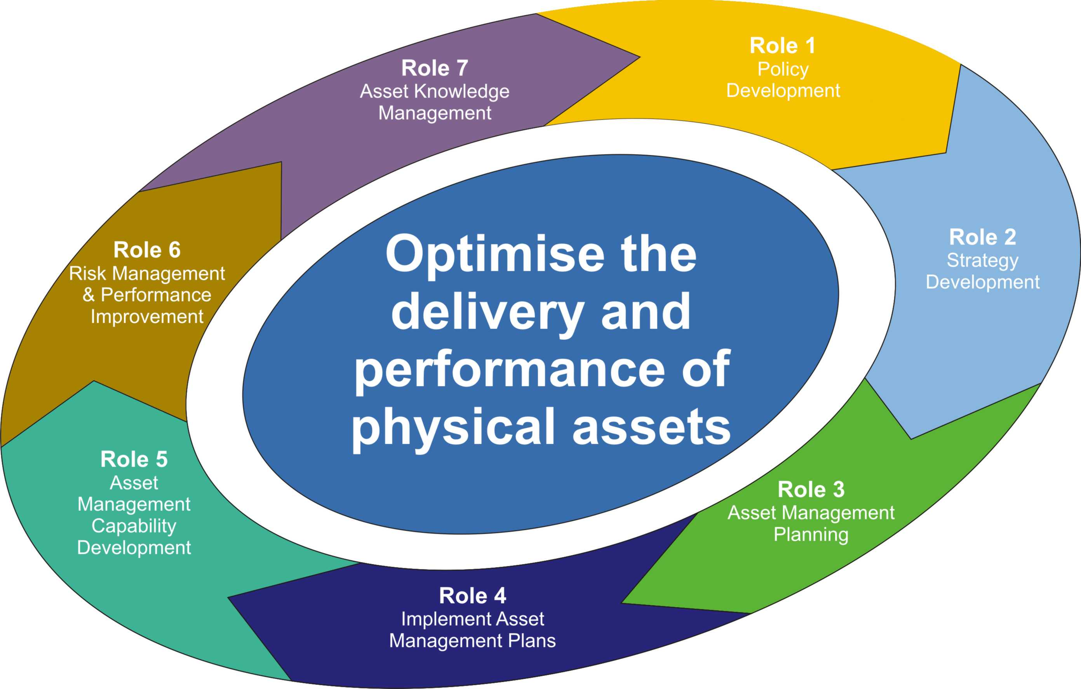
The roles demonstrate a structured top down cascading approach, where the roles performed lower in the organization are developed to support the higher level roles, and the organization uses feedback to refine and improve their performance.
In my next newsletter article, more detail about PAS 55 key purpose and roles.

Upcoming
Please advise me, if there are other topics on maintenance management, project management, or physical asset management issues that would you would find of interest.
The C-MORE (Centre for Maintenance Optimization and Reliability Engineering) centre at the University of Toronto is organizing their 5th annual IMEC (International Maintenance Excellence Conference) conference for September 9 to 11, 2009. For more information, see: http://imec.ca .
PEMAC will be organizing their annual MainTrain 2009 conferences, this year with a new venue in Atlantic Canada at St. John’s, NL. MainTrain will be in Edmonton, AB on September 28 to 30, 2009; in St. John’s, NL on October 26 to 28, 2009; and in Toronto, ON on November 23 to 26, 2009. For more information, see http://www.maintrain.ca

Contact Us
To provide feedback on this newsletter, including comments on past articles, ideas for future articles, or to remove your name from distribution of this newsletter, please e-mail me at len@asset-management-solutions.com.
Please feel free to contact us to discuss any of your physical asset management requirements. For more information on how we can help you, please contact me directly. See our web site at: http://www.asset-management-solutions.com for other information on Asset Management Solutions, including asset management issues and solutions.
Copyright 2003 - 2009 © Leonard G. Middleton – Asset Management Solutions

