Copies of current and past newsletters can be found at: http://www.asset-management-solutions.com/newsletters.htm
Newsletter for December 2010
I appreciate receiving your comments on this newsletter and any suggestions for future topics. If there is someone you know who would be interested in receiving this newsletter, please feel free to forward the newsletters to them, or forward their e-mail address to me and I will include them in the distribution of future newsletters. If you wish to remove your name from distribution of this newsletter, please respond via e-mail. Please see “Contact Us” at bottom for e-mail address for feedback, comments and removal from distribution.
To keep this newsletter relatively short, this is intended to be a broad overview of issues for physical asset management, rather than a comprehensive discussion of the topic.

Post Project Evaluation – A Long Term View
If one spends enough time involved with equipment, you get to see different perspectives. And so with a number of years of professional practice, I have both spent time in maintenance and plant engineering, and on the other side project management and engineering delivering assets into operating sites.

Project Cumulative Costs
Take a look at the graphic below, and see how you would interpret the results, with the green line being the project baseline determined during the project planning phase, and the red line being the project actuals. Think of it as a sort of an asset management Rorschach ink blob test.
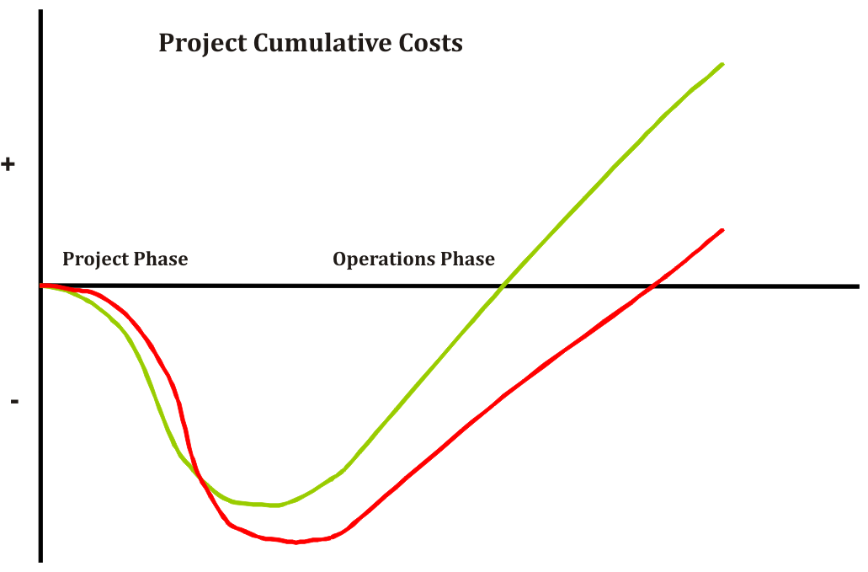

Evaluation of Project Execution
Those involved in managing projects will of course recognize the classic project “S” curve, where the project starts slowly, then rapidly increases as more resources can be effectively used, then the extended effort in getting the project finished with little to show for the effort, and finally the slow ramp up during the operations start up.
Many will also recognize the issue that the project is both late and over budget; two critical project management measures where this project has not performed well. In fact with many organizations, schedule, as long as it is fairly close is not a big consideration. However, given that the actual costs related the project can be often measured down to the nearest dollar, it is often the most significant consideration for some organizations. This is often the case where projects are managed by a dedicated group (e.g. Engineering, or Project Management group).
From a business perspective, both project schedule and budget compliance are important, as they have an impact on meeting forecasts for revenue, profitability and cash flow of the organization. When managing projects, project managers may often need to make compromises between project schedule, budget and deliverables, and will do so based upon the organization’s priorities. If major stakeholders have incentives based upon organizational performance, then for significant projects budget compliance will be critical and closely watched. If the problem is severe enough, there may be an investigation into what went wrong with the project.

Long Term Impact of Projects
Project deliverables are of course important to the end users of the projects, including those that have to operate and maintain them, a situation that can sometimes be seen as being overlooked by those delivering the projects. One of the long term issues with projects is that after they are delivered, to make significant changes may required significant resources to change the facts upon the ground, , if they can be changed at all, particularly when those facts are embodied in concrete and steel. The result is often the project remains as delivered, with only minor changes, at most.
What does that have to do with the above graph?
There is a difference in the slope of the operations phase between the project baseline and the actual project results. That slope (i.e. $ per unit of time) defines the financial return of the project. In the above case, the point where the project pays back the investment made in it (i.e. where cash flow from return crosses zero cumulative costs), is delayed in part by the schedule delay and the budget overrun, but also by the lower rate of return from the project as shown by the flatter slope.
The poor rate of return could be caused by higher than forecast costs to operate and maintain e.g. expected savings not achieved due to higher materials costs, higher energy costs, or higher labour costs. It could be caused by lower than forecast throughput e.g. low OEE – Overall Equipment Effectiveness. At one client I worked with, the issues related to one project were such that they were only able to operate the plant at around 70% of designed value, certainly well below the forecast return. As noted above, the only way to change the situation might be to invest considerable resources to fix the deficiencies, otherwise the organization lives with the reduced return for the life of the project i.e. until the system is de-commissioned and taken out of service. As well as the financial investment, there may also be considerable political risk for major stakeholders involved within the organization.

Post Project Audit
What can be done about it?
Some organizations perform post project reviews to determine lessons learned i.e. what during the project worked well, and what could have been done better. There may be criteria used for determining which projects should be reviewed, including all projects over a certain value, all projects outside of acceptable budget and / or schedule tolerances, or projects selected at random. Often they are performed shortly after the project is complete, as the project team may not have yet gone onto their new assignments, and their memories are still relatively fresh.
The constraint is that it may be too soon to know or understand what the actual return of the project is or will be. It may be necessary to wait a year or more for the operation and maintenance of the project deliverables to stabilize before they can be properly evaluated.
That may seem like a relatively long time to find out, but then what is the method your organization currently uses to determine how well the project delivered the results it was intended to deliver?

Upcoming
Please advise me, if there are other topics on maintenance management, project management, or physical asset management issues that would you would find of interest.
PEMAC (Plant Engineering and Maintenance Association of Canada) will again be organizing their MainTrain conferences this year. More detail will be provided, as it becomes available.
CMORE (Centre of Maintenance Optimization and Reliability Engineering) at the University of Toronto are organizing their annual IMEC conference. More detail will be provided, as it becomes available.

Contact Us
To provide feedback on this newsletter, including comments on past articles, ideas for future articles, or to remove your name from distribution of this newsletter, please e-mail me at len@asset-management-solutions.com.
Please feel free to contact us to discuss any of your physical asset management requirements. For more information on how we can help you, please contact me directly. See our web site at: http://www.asset-management-solutions.com for other information on Asset Management Solutions, including asset management issues and solutions.
Copyright 2003 - 2010 © Leonard G. Middleton – Asset Management Solutions

