Copies of current and past newsletters can be found at: http://www.asset-management-solutions.com/newsletters.htm
Newsletter for November 2013
I appreciate receiving your comments on this newsletter and any suggestions for future topics. If there is someone you know who would be interested in receiving this newsletter, please feel free to forward the newsletters to them, or forward their e-mail address to me and I will include them in the distribution of future newsletters. If you wish to remove your name from distribution of this newsletter, please respond via e-mail. Please see “Contact Us” at bottom for e-mail address for feedback, comments and removal from distribution.
This month’s newsletter is by Ben Stevens, and Ben can be reached at StevensB@kingston.net.
To keep this newsletter relatively short, this is intended to be a broad overview of issues for physical asset management, rather than a comprehensive discussion of the topic.

Too Many KPI’s! -- Testing the Value of Your KPI’s
How many times have we heard the cry “too many KPI’s – which ones should I prioritise?”
Here’s a simple method of sorting out the ones that work from the ones that should be junked:
- First define the major objectives of your KPI’s.
- Next ask some penetrating questions about whether your KPI’s match these objectives
- Then build a simple scorecard (a sort of KPI that measures your KPI’s???)

Some Proposed Objectives of KPI’s
- To focus attention on a critical status or trend
- To measure it effectively and promptly
- To quickly identify a key change in the trend or status
- To prompt a change in behaviour
- Easily measured, easily understood, clear unambiguous message

Some Skill-Testing Questions
- Is the status or trend really critical to the performance of the user and the equipment?
- Does it have a real impact on the profitability or effectiveness of the organization?
- Does the measurement, analysis and reporting process properly reflect the performance of the equipment?
- Are the results quickly available?
- If there is a change in the status or trend, does this rapidly show up in the KPI?
- If a change in the trend or status does occur, does it prompt a meaningful change in the behaviour of the Maintenance and Operations team?
- Does this behaviour change happen quickly enough to reverse or enhance the trend during the current period?
- Is the measurement and analysis process easy and precise?
- Is the measurement and analysis process well understood by the Maintenance team?
- Is the output message clearly understood by the Maintenance team and by Management?
- Do people read it and use it?

Scorecard
Here’s a simple scorecard – set your own objectives and parameters; use your own scoring method; and set your own “junk it” level:
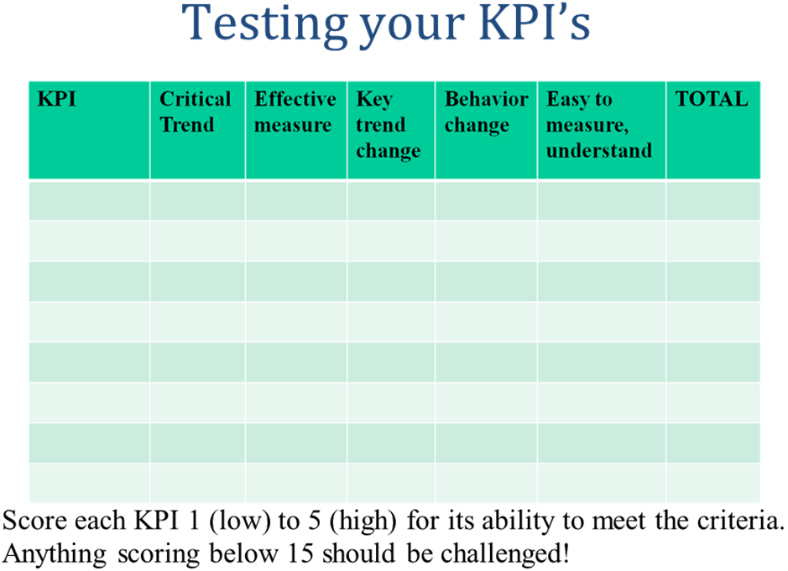
Ideas, suggestions, and questions wanted please!
- Ben Stevens

Upcoming
Please advise me, if there are other topics on maintenance management, project management, or physical asset management issues that would you would find of interest.
Last chance for this year, as the 2013 version of PEMAC’s (Plant Engineering and Maintenance Association of Canada) MainTrain conference will be held in Calgary, from November 18 to 21, 2013. For more information, see: www.MainTrain.ca.

Contact Us
To provide feedback on this newsletter, including comments on past articles, ideas for future articles, add names for other interested colleagues or friends (please copy them with your request), or to remove your name from distribution of this newsletter, please e-mail me at len@asset-management-solutions.com.
Please feel free to contact us to discuss any of your physical asset management requirements. For more information on how we can help you, please contact me directly. See our web site at: http://www.asset-management-solutions.com for other information on Asset Management Solutions, including asset management issues and solutions.
Copyright 2003 - 2013 © Leonard G. Middleton – Asset Management Solutions

