Copies of current and past newsletters can be found at: http://www.asset-management-solutions.com/newsletters.htm
Newsletter for October 2015
I appreciate receiving your comments on this newsletter and any suggestions for future topics. If there is someone you know who would be interested in receiving this newsletter, please feel free to forward the newsletters to them, or forward their e-mail address to me and I will include them in the distribution of future newsletters. If you wish to remove your name from distribution of this newsletter, please respond via e-mail. Please see “Contact Us” at bottom for e-mail address for feedback, comments and removal from distribution.
To keep this newsletter relatively short, this is intended to be a broad overview of issues for physical asset management, rather than a comprehensive discussion of the topic.
If you have any questions or topics you would like to have us discuss, please send them to me.
Further changes have resulted in me again providing management consulting services under the Asset Management Solutions banner. I will continue to collaborate with Ben to continue to share our knowledge and insights through these newsletters. We have a number of readers worldwide and feel we have been providing a useful service to those who might otherwise want or need the alternate insights provided.
This month’s newsletter covers Root Cause Analysis – and therefore is a little longer than usual. It’s a really good article with lots of useful ideas built into it. Our thanks to Abdul Azeez of Bentley, who can be reached at: Abdul.Azeez@bentley.com, or on LinkedIn at https://www.linkedin.com/pulse/perfect-rca-program-abdul-azim-azeez-1?trk=pulse_spock-articles
Note to Canadian subscribers: With the recent change in anti-spam legislation, we are required to ask you to opt-in to confirm your wish to continue to receive our newsletter. However, as we have never tracked the Canadian subscribers from our international ones, I am uncertain as to how to identify the Canadian subscribers who did not opt-in. As noted in the first paragraph above of all the newsletters, please contact us to have your name removed from the distribution list. We have honoured all past requests for removal and will continue to do so in the future.

“The Perfect RCA Program”
The purpose of this article is to outline the objectives, ingredients, and the recipe of 'The Perfect RCA Program.' It will not go into detail regarding the available methods/tools of performing RCA, and RCA Software - many such articles can be found elsewhere.

Objectives
The objectives of The Perfect RCA Program can be summarized by the acronym TREE.
T: Timely – RCAs as well as their resultant action plan are carried out in a Timely manner.
R: Right – the analysis is Right; the RCA is done correctly.
E: Enacted – the recommendations from the analysis are Enacted upon.
E: Evaluated – follow up on the implemented actions to Evaluate effectiveness.

Ingredients
- Structured Incident Reporting
- Triggers – when should an RCA be carried out?
- Competency Framework – Champion, Practitioner, Analyst, Participants & Managers.
- Structured RCA Reports
- Software – storage, search, dashboards, failure coding, etc.

1. Structured Incident Reporting
Incidents (or ‘failure events’) can be reported by any person in the organization; however, a structured reporting system must be followed.
The Perfect RCA Program require an organization to have a standardized incident-reporting template that contains factual information. Generally, the incident report should provide the following information:
- Who? – Personnel involved directly or indirectly to the incident, and a description of their involvement.
- What? – In order to get a chronological overview; a description of what took place before, during, and after the incident. What mitigating immediate actions were taken? What were the consequences? What evidence/information were collected?
- When? – Date/time of the incident, and the incident report. When was the incident discovered? When was the incident brought under control?
- Where? – Location of the incident.
- Why? – Why did the incident occur? An initial assessment of its cause.
- How? – How did the incident become evident? How is this incident related to other incidents (if applicable)? How was evidence/information obtained?

In order to process a well-organized report, the template should be detailed accordingly such that the above information is obtained accurately, objectively, and completely.

2. Triggers – when should an RCA be carried out?
An RCA classification system requires definition based on risk (frequency and consequence) of a failure event. A ‘failure event’ is an event that has a negative impact to the organization. For example, an asset failed, an injury occurred, or bills were not paid on time.
The sample below only considers economic loss; The Perfect RCA Program requires other loses (associated to safety, environment, reputation) also be considered and in line with the economic loss ranking.

Failure Event | Consequence | RCA Class (Risk Rating)
Event resulted in total economic loss of > $20M | A | A | A | A
Event resulted in total economic loss of $2M to $20M | B | B | A | A
Event resulted in total economic loss of $200k to $2M | C | C | B | A
Event resulted in total economic loss of $20k to $200k | D | D | C | B
Economic loss of < $20k | E | E | D | C
Event Occurrence: |  | 1st | 2nd | 3rd

Based on the above classification, if a failure event costs $200 to $2M – the first time it occurs, it will be classified as a ‘C’ RCA Class. If it happens the second time, it will go to a higher classification, namely, ‘B’ and so on.
Once the RCA Class is determined, the following is triggered:
- Class A, B and C – assigned to a Champion, Practitioner and Analyst, respectively, to own/facilitate the analysis.
- Class D & E – share lessons learned from the incident report; no RCA required.

3. Competency Framework
The Perfect RCA Program contains 4 levels of competencies, the certification process goes from the lowest level to the higher level i.e. one can only be certified at a higher level after the lower level certification is achieved. Each level contains a number of questions that one must be able to answer and requirements that one must meet.
Participants/Managers – level 1
- What is an ‘Incident Report’? What does it contain?
- What does RCA stand for?
- Describe at least 5 goals of RCA.
- Describe the main steps involved in performing an RCA.
- What does TREE stand for?
- What are your responsibilities as the ‘participants’ in a RCA?
- Is it better to not give any answer or to give a wrong answer?
- Describe the process used in our organization to determine if a RCA is needed.
- Describe our organization’s RCA flow from the issuance on an Incident Report to the completion of the RCA.
- Who are involved at each stage of the RCA flow and what are their responsibilities?
- Does the RCA facilitator/owner have to be a subject matter expert?
Analyst – level 2
- What is included in the ‘incident description’ of an RCA report?
- Give 3 examples of corrective and preventive actions.
- Describe the 4 R’s of incident response. [A: Recognize, React, Report, Recover]
- Should the RCA team be made up of experts only? Explain your response.
- State 3 benefits of a team approach to RCA?
- Describe 3 sources of information and rank them from most reliable to least reliable. [A: records/measurements, expert opinions/physical observations, personal emotions/feelings]
- What is the difference between an ‘influencing contributory factor’ and a ‘casual contributory factor?’
- Describe the RCA tool known as ‘brain-writing.’
- Draw a ‘fishbone diagram’ and describe its components.
- Describe the ‘five why’ RCA method.
- Should the root causes be decided upon by the RCA facilitator or the team?
- Draw a simple ‘fault tree’ and describe its components / gates.
- Describe the importance of documenting an RCA.
Practitioner – level 3
- Describe 3 important aspects to pay attention to while interviewing to gather RCA information.
- Describe the 4 types of ‘barriers’ and rank by effectiveness. [A: physical, natural, human action, administrative]
- Ability to perform lifecycle costing analysis.
- Superior report writing ability.
- Proven record of the ability to conduct/control multi-disciplined meetings.
- Have successfully completed at least 3 RCAs.
- A good understanding of RCA tools and their applicability.
Champion – level 4
- Ability to train staff on the RCA process.
- Ability to develop and manage RCA programs.
- Demonstrated ability to perform complex probabilistic quantitative (Monte Carlo Simulation) analysis.
- Ability to perform Reliability Modelling and Weibull analysis.
- Understanding of RCM process.
- In-depth knowledge of the organization’s business environment.
- Good understanding of (advanced) condition monitoring and NDE tools.
- Knowledge of industry specific standards applicable to the organization.
Furthermore, The Perfect RCA Programs requires organizations to develop a reference book(let) containing the overview of the process as well as a description of the industry tools used during an RCA. The description should contain brief instructions regarding how to use the tools, and their applicability. Some tools are listed below:
- Brainstorm/brain-write
- Fishbone Diagram
- Fault Tree Analysis
- Pareto Chart
- Change Analysis
- Chronological Event Charting
- Barrier Analysis
- Five-Whys
- Failure Mode and Effect Analysis

4. Structured RCA Reports
The reporting structure is dependent upon the RCA classification. The following are the required sections for reporting on a Class A RCA:
- Executive Summary
- Incident Description & Background
- Pre-investigation Risk Assessment (RCA Classification)
- Investigation Team
- Information & Evidence
- Contributory Factors
- Root Causes
- Lessons Learned
- Recommendations (Action Plan)
- Arrangements for Sharing Learning
- Distribution List
- Appendices
For lower level classes, fewer details would be required.
Ensure that recommendations are shared with the risk management function of the organization. A fundamental part of the organization’s risk management program is the development and maintenance of a risk register. The failure events which are subjected to root cause analysis are likely to be examples of such risks. As the register should include the action plans for the reduction of each identified risk, improvement strategies associated with the RCA should also be linked to the risk register.

5. Software
Software is used as an enabler of The Perfect RCA Program, to perform the following functions:
- Act as a structured (query-able) database that holds the RCAs and its attachments.
- Provide a routing system for ease of information exchange.
- Track action items.
- Produce reports and dashboards to enable optimization.
- Reporting templates.
The software should ideally be integrated with the ‘main’ software used in the organization – for most industrial organizations, the ‘main’ software would equate to their CMMS/ERP solution.
Having such a software is not a prerequisite of successfully implementing The Perfect RCA Program but it will definitely make the process go faster.

Recipe
- An incident report is submitted by any member of the organization to a designated person, namely, the RCA Moderator.
- The RCA Moderator determines the RCA Class and, accordingly, assigns the person to facilitate the RCA, namely, the RCA Owner.
- The RCA Owner is responsible for the ‘T’ and the ‘R’ of TREE. To ensure that the RCA is done Right and in a Timely manner by the team that he put together, namely, the RCA Team.
- The RCA Team carry out the analysis under the leadership of the RCA Owner and develop the action plan, which is forwarded back to the RCA Moderator.
- The RCA Moderator is now responsible for the two E’s of TREE. To ensure that the action plan is Enacted upon and to follow up at a later stage to Evaluate its effectiveness.
- The final report is put together by the RCA Owner.
- Lessons learned is then shared with relevant personnel across the organization – by the RCA Moderator.
The recipe of The Perfect RCA Program:
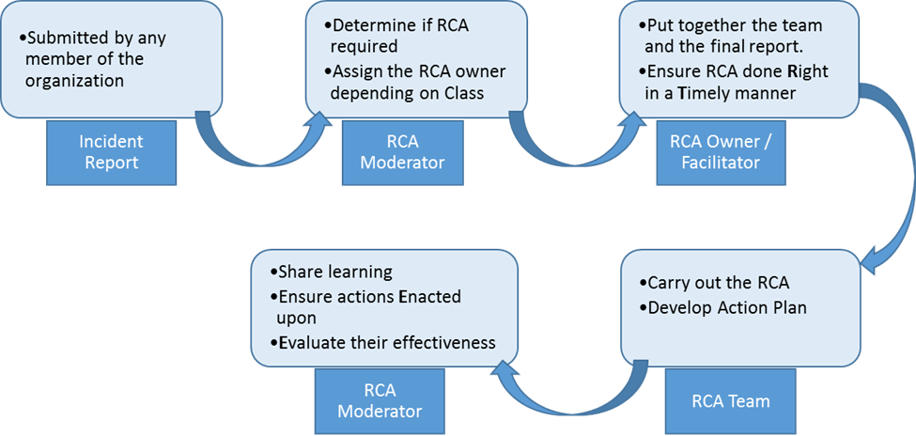

As always, your comments and suggestions are most welcome.

Upcoming
Please advise me, if there are other topics on maintenance management, project management, or physical asset management issues that would you would find of interest.
MainTrain 2016 will be held in the Toronto area. For more information, see: www.MainTrain.ca.

Contact Us
To provide feedback on this newsletter, including comments on past articles, ideas for future articles, add names for other interested colleagues or friends (please copy them with your request), or to remove your name from distribution of this newsletter, please e-mail me at len@asset-management-solutions.com.
Please feel free to contact us to discuss any of your physical asset management requirements. For more information on how we can help you, please contact me directly. See our web site at: http://www.asset-management-solutions.com for other information on Asset Management Solutions, including asset management issues and solutions.
Copyright 2003 - 2015 © Leonard G. Middleton – Asset Management Solutions

