Copies of current and past newsletters can be found at: http://www.asset-management-solutions.com/newsletters.htm
Newsletter for January 2017
I appreciate receiving your comments on this newsletter and any suggestions for future topics. If there is someone you know who would be interested in receiving this newsletter, please feel free to forward the newsletters to them, or forward their e-mail address to me and I will include them in the distribution of future newsletters. If you wish to remove your name from distribution of this newsletter, please respond via e-mail. Please see “Contact Us” at bottom for e-mail address for feedback, comments and removal from distribution.
To keep this newsletter relatively short, this is intended to be a broad overview of issues for physical asset management, rather than a comprehensive discussion of the topic.
If you have any questions or topics you would like to have us discuss, please send them to me.
Further changes have resulted in me again providing management consulting services under the Asset Management Solutions banner. I will continue to collaborate with Ben to continue to share our knowledge and insights through these newsletters. We have a number of readers worldwide and feel we have been providing a useful service to those who might otherwise want or need the alternate insights provided.
Note to Canadian subscribers: With the change in anti-spam legislation, we are required to ask you to opt-in to confirm your wish to continue to receive our newsletter. However, as we have never tracked the Canadian subscribers from our international ones, I am uncertain as to how to identify the Canadian subscribers who did not opt-in. As noted in the first paragraph above of all the newsletters, please contact us to have your name removed from the distribution list. We have honoured all past requests for removal and will continue to do so in the future.

Importance of Working Capital Management
Certainly, an odd topic for asset management, maintenance, and reliability practitioners, but one that directly impacts their work and focus.

Revenue, Cost, Volume, and Profitability
The diagram below shows the starting model for our discussion on working capital and has been used in earlier newsletters (see April 2008 newsletter).
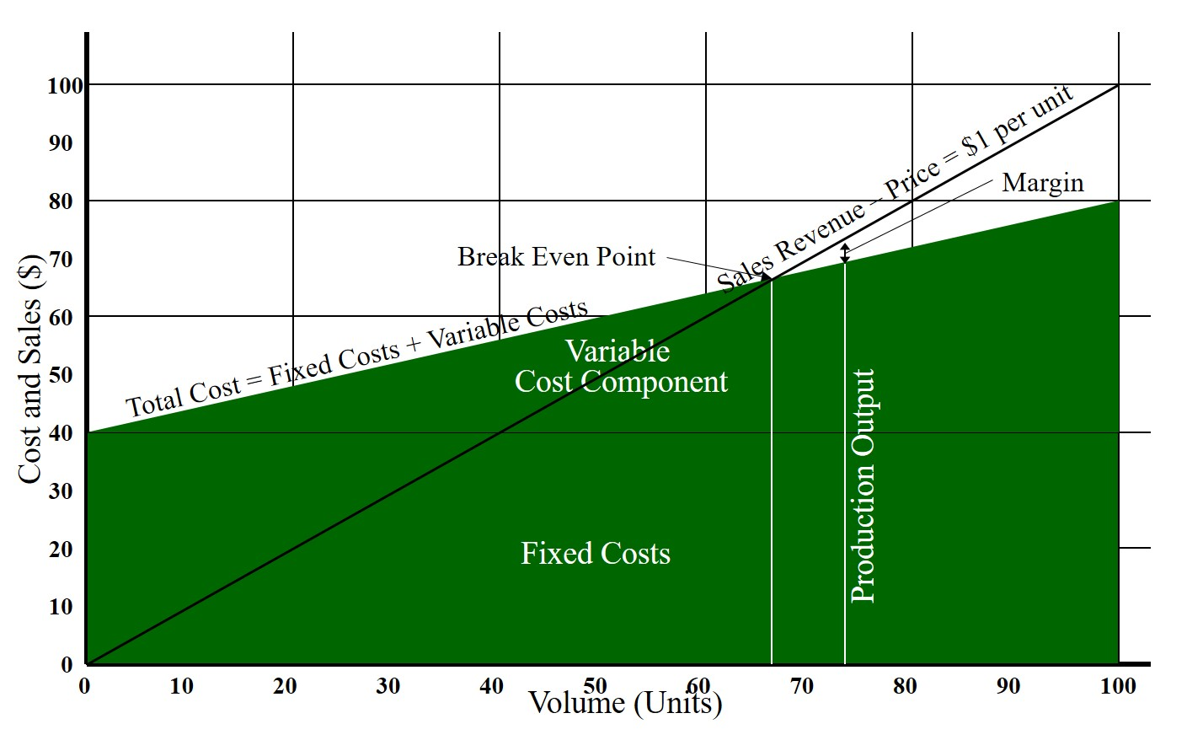

Understanding Cash Flow in Operations
We obviously understand the importance of profitability, but it is important to understand the critical issue as to why is cash flow important to an organization’s viability. Interestingly, profitable organizations can go bankrupt, due to a cash flow crisis, with it only being a matter of timing. Paradoxically, unprofitable organizations with sufficient resources can continue to operate for as long as their financial resources last.
For unprofitable organizations continuing with sufficient resources, the situation of the early 21st century with the “dot.com bust” is an excellent example. Many of the dot.com companies were never profitable, but as long as investors kept investing by injecting capital in them, they survived. It was only when the realization came to investors that they were throwing good money after bad, did the cash flow dry up and the organizations became insolvent and went bankrupt.
In the situation faced in normal operations, there is often a time lag between when the cost of operations (materials, labour, utilities, fixed costs and overheads) is incurred and when the revenue is collected, requiring the short fall in working capital to be addressed for the organization to continue to operate.

Baseline Cash Flow Example
Using the above graph as an example, at Volume of 75 Units:
- Fixed Costs + Labour = $40
  - Assume all fixed costs + labour are payable at beginning of the month.
- Variable Costs = Volume x 40/100 = $30
  - Assume variable costs are $25 in materials and $5 in utilities;
  - And a month’s worth of material on hand, payable after 30 days, and utilities payable after 30 days.
- Revenue = $75
  - Assume product is produced and sold immediately at end of month, and is receivable net 30 days.
- Margin = $5
Note that financial accounting does not directly address the timing issue.

Baseline Cash Flow Timing
Timing (Days) | Item | Cash Flow Impact | Cumulative Cash Flow
1 | Fixed Costs + Labour | -$40 | -$40
30 | Materials | -$25 | -$65
31 | Fixed Costs + Labour | -$40 | -$105
60 | Materials | -$25 | -$130
60 | Utilities | -$5 | -$135
60 | Revenue | +$75 | -$60
61 | Fixed Costs + Labour | -$40 | -$100
90 | Materials | -$25 | -$125
90 | Utilities | -$5 | -$130
90 | Revenue | +$75 | -$55

The amount of the short fall in working capital (e.g. day 60) will need to be financed. Potential solutions in normal circumstances include maintaining and using a line of credit, using short term loans (potentially secured with short term assets e.g. accounts receivable, inventory, etc.), having capital reserves (e.g. cash in the bank) to cover the short fall, or delaying payments to vendors. Delaying payment to vendors can impact service level (e.g. delay delivery, poorer quality of product or service, etc.) from them and could impact future operations.
To effective manage cash flow, the accounting department responsible for accounts receivable (i.e. money the organization gets paid for their credit sales e.g. payment within 30 days) will need to ensure payment is collected promptly from their customers.
In extraordinary circumstances with severe cash flow issues, it might be necessary to sell the more liquid assets (likely at a discount). The organization would normally process these assets differently to maximize the value of those assets, but instead sell them to finance the extraordinary short fall to prevent or delay insolvency. This can include selling raw materials, WIP (Work-In-Process), or finished goods inventory. Another solution is to selling the accounts receivable to a third-party “factor”, who buys them at a discount and to collect them later, while providing immediate cash payment to improve the organization’s cash flow / liquidity. Discounts can result in the range of 70 to 85% of the invoiced amounts being paid, and / or interest of 1.5% to 4.5% for 30 days depending upon the perceived risk (i.e. ability and timing of collecting accounts receivable invoices) to the third-party factor. Selling inventory at a discount that will later need to be replenished at full price and factoring of accounts receivable are extraordinary activities that will be done only if other activities are not successful in addressing in addressing the short term cash flow.

Impact of Increased Volume
To see the impact of increasing volume, will change the scenario with “Great News, as the Business is Growing!!!”
- Marketing & Sales has signed on a new customer!!
- Using our current prices in a new geographical area it will double our product demand!!
- Will need to duplicate the operational infrastructure (and its resulting cost structure) in a new location.
  - As we will use some of our experienced staff and workforce for start-up of the new facilities, we expect that our efficiency will remain the same.
Analysis is only of Operations working capital requirements, and does NOT include capital investment requirements for any new facilities and operations infrastructure.

Increased Volume Cash Flow Timing Projections
Timing (Days) | Item | Cash Flow Impact | Cumulative Cash Flow
1 | Fixed Costs + Labour | -$80 | -$80
30 | Materials | -$50 | -$130
31 | Fixed Costs + Labour | -$80 | -$210
60 | Materials | -$50 | -$260
60 | Utilities | -$10 | -$270
60 | Revenue | +$150 | -$120
61 | Fixed Costs + Labour | -$80 | -$200
90 | Materials | -$50 | -$250
90 | Utilities | -$10 | -$260
90 | Revenue | +$150 | -$110

With the higher volume, the working capital requirements increases proportionally with the increased volume (doubled in above example). This is a significant risk with a rapidly expanding business, if not effectively managed.

Impact of Timing of Cash Flows
The scenario is now changed to address the impact of cash flow to vendors and from customers.
“Not So Great News”, as our Sales & Marketing did not initially mention it, but as cash flow considerations are not part of their performance measures (and compensation), and so when they negotiated and signed the contract, the terms were payable net 60 days, rather than 30 days.
Now our material suppliers are concerned about our ongoing viability due to potential cash flow issues and with the higher perceived risk, want payment upon receipt of material.
But profitability will not change!

Impact of Delayed Revenue and Payment Upon Receipt of Materials
Timing (Days) | Item | Cash Flow Impact | Cumulative Cash Flow
1 | Fixed Costs + Labour | -$80 | -$80
1 | Materials | -$50 | -$130
31 | Fixed Costs + Labour | -$80 | -$210
31 | Materials | -$50 | -$260
60 | Utilities | -$10 | -$270
61 | Fixed Costs + Labour | -$80 | -$350
61 | Materials | -$50 | -$400
90 | Utilities | -$10 | -$410
90 | Revenue | +$150 | -$260

In this situation, the amount of working capital required has increased further and the short fall will need to be financed to ensure smooth and ongoing operation, as if the payment is not made to the material vendor, operations stops from lack of materials. The result of the delayed collection from the customer extends the amount and duration the short fall exists.

Impact on Asset Management, Maintenance, and Reliability
Working capital management is managing the organization’s short term assets and liabilities to ensure sufficient resources to continue operations and avoid costly interruptions to operations and resultant negative impact on revenue generated by operations.
Given the long-lived nature of capital projects, they could be financed over a long term using business loans or bonds, which then get repaid through cash generated by operations. However, as working capital is an ongoing issue related to operations, it needs to be managed within current operations including the revenue it generates and the costs it incurs, and remains a short-term focus. The result is that capital project expenditures need to be planned within the cash flow generated and incurred by operations and may on occasion be competing for a part of the same pool of capital.
The result especially for small or rapidly expanding business, is that expenditures may need to be reduced or deferred to manage cash flow in the short term. However, like factoring of accounts receivable and selling at a discount inventory they will need to replenish later at its regular price, the organization will need to understand the cost and impact to the organization of their decisions.
Some potential areas of focus to address cash flow in the short to medium term:
- Greater focus on importance of payback period of investments and capital projects, as well as ROI (Return-On-Investment);
- Using staged phases for projects or investments that can be easily and quickly started, stopped, and restarted with minimal increase in overall costs or loss of value (e.g. rework, mobilization / demobilization costs and impact, etc.);
- Reduction or deferment of expenses and investments not used in operations (e.g. MRO / spare parts inventory, maintenance overhaul / betterment projects, etc.); and
- Strong focus on reduction in costs and resulting cash flow in areas outside of operations (e.g. deferred or reduced regular maintenance, reduced project size or functionality, deferred projects / investments, reduction is size of maintenance, reliability, or engineering and project departments and workforce, etc.).

Upcoming
Please advise me, if there are other topics on asset management, maintenance, reliability, or project management issues that would you would find of interest.
The 2017 version of PEMAC’s (Plant Engineering and Maintenance Association of Canada) MainTrain will be held in Saskatoon. For more information, see: www.MainTrain.ca.

Contact Us
To provide feedback on this newsletter, including comments on past articles, ideas for future articles, add names for other interested colleagues or friends (please copy them with your request), or to remove your name from distribution of this newsletter, please e-mail me at len@asset-management-solutions.com.
Please feel free to contact us to discuss any of your physical asset management requirements. For more information on how we can help you, please contact me directly. See our web site at: http://www.asset-management-solutions.com for other information on Asset Management Solutions, including asset management issues and solutions.
Copyright 2003 - 2017 © Leonard G. Middleton – Asset Management Solutions

