Copies of current and past newsletters can be found at: http://www.asset-management-solutions.com/newsletters.htm
Newsletter for April 2017
I appreciate receiving your comments on this newsletter and any suggestions for future topics. If there is someone you know who would be interested in receiving this newsletter, please feel free to forward the newsletters to them, or forward their e-mail address to me and I will include them in the distribution of future newsletters. If you wish to remove your name from distribution of this newsletter, please respond via e-mail. Please see “Contact Us” at bottom for e-mail address for feedback, comments and removal from distribution.
To keep this newsletter relatively short, this is intended to be a broad overview of issues for physical asset management, rather than a comprehensive discussion of the topic.
If you have any questions or topics you would like to have us discuss, please send them to me.
Further changes have resulted in me again providing management consulting services under the Asset Management Solutions banner. I will continue to collaborate with Ben to continue to share our knowledge and insights through these newsletters. We have a number of readers worldwide and feel we have been providing a useful service to those who might otherwise want or need the alternate insights provided.
Note to Canadian subscribers: With the change in anti-spam legislation, we are required to ask you to opt-in to confirm your wish to continue to receive our newsletter. However, as we have never tracked the Canadian subscribers from our international ones, I am uncertain as to how to identify the Canadian subscribers who did not opt-in. As noted in the first paragraph above of all the newsletters, please contact us to have your name removed from the distribution list. We have honoured all past requests for removal and will continue to do so in the future.

Conditional Probability of Failure Patterns and their Impact to Maintenance
This newsletter is to address the difference in conditional probability of failure patterns, and the impact on how best to maintain them.

Conditional Probability of Failure Patterns
Definition: Conditional probability of failure is defined as the likelihood an item will fail in the next period, assuming it has not yet failed.
Or put another way, given an item has survived to this point, will its probability of failure increase (e.g. age related failures), decrease (e.g. infant mortality failures), or remain the same (e.g. random failures).
As part of the Nowlan and Heap study into failures of civilian aircraft published in 1978, they identified six different conditional probability of failure patterns symbolically shown (i.e. not to scale) and the percentage by failure patterns, as follows:

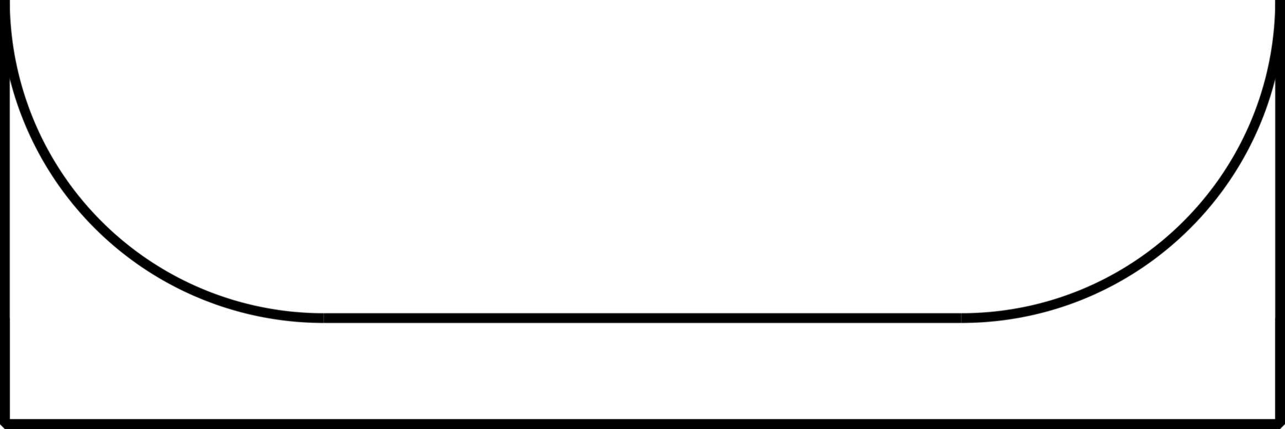
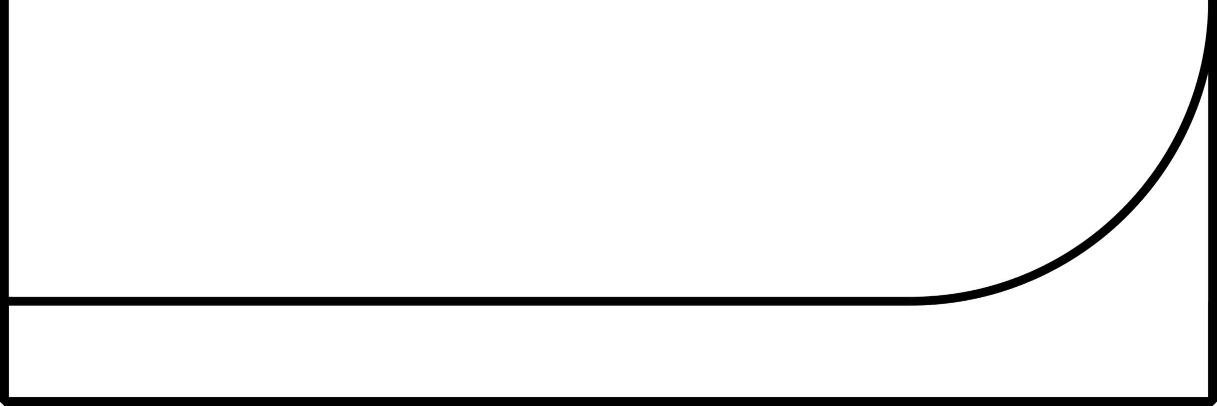
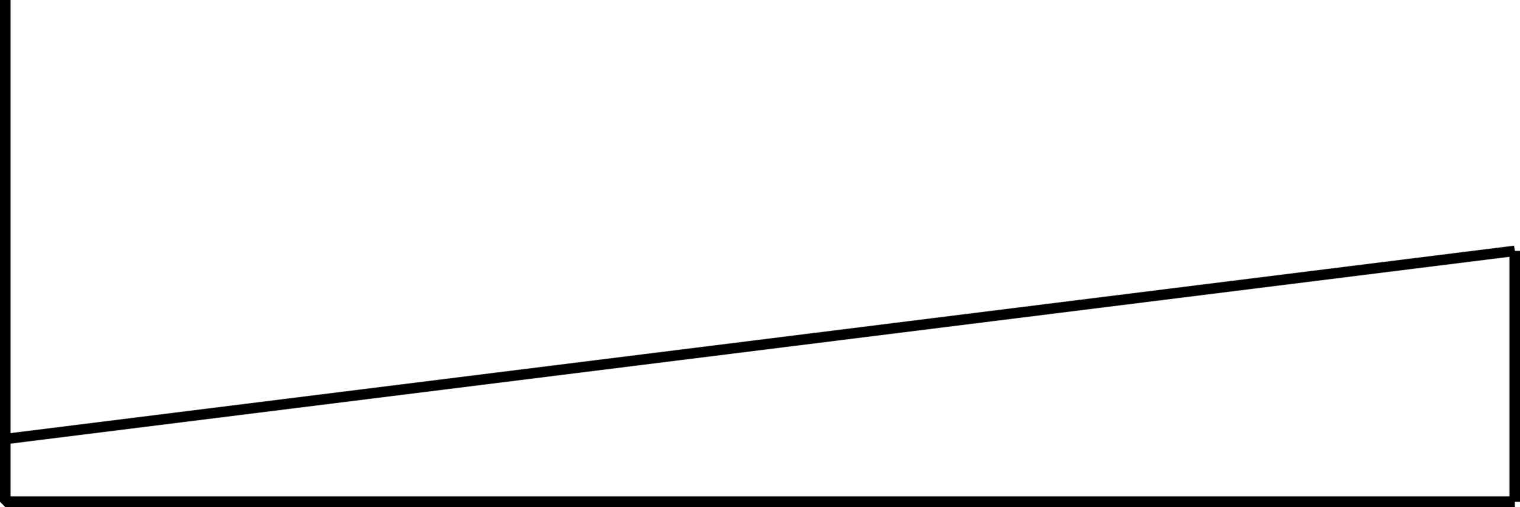
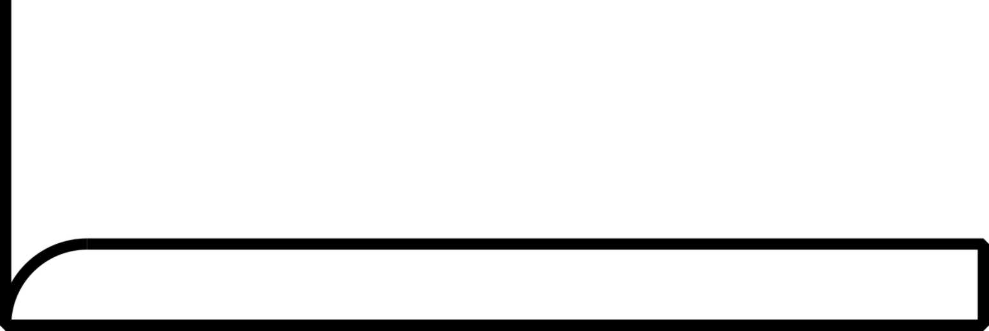
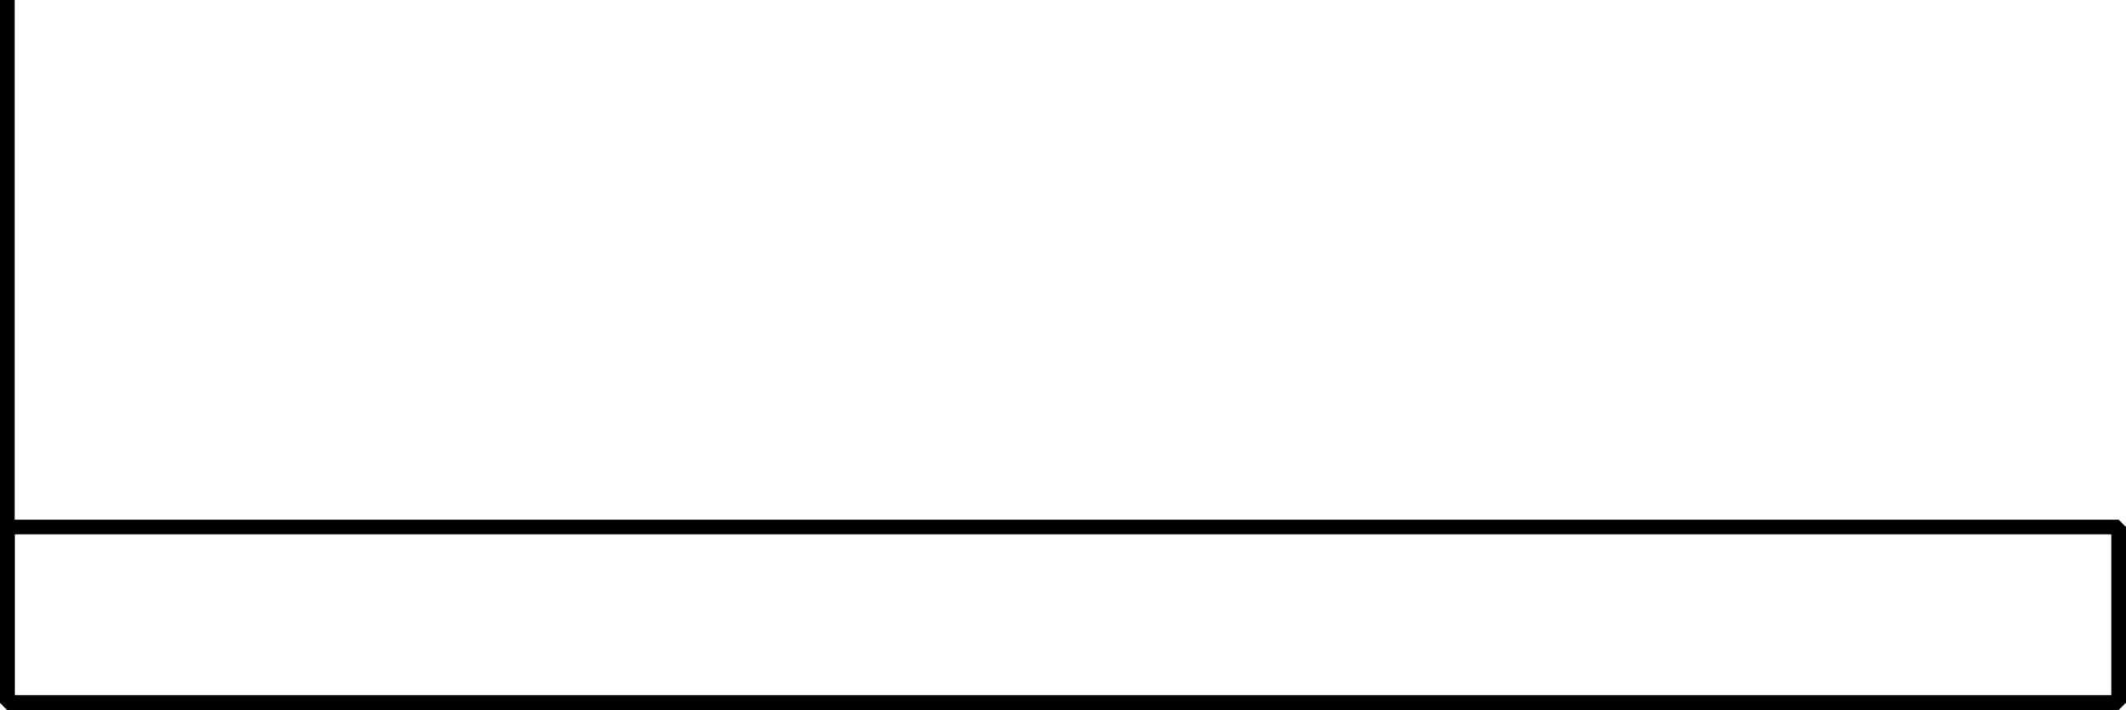
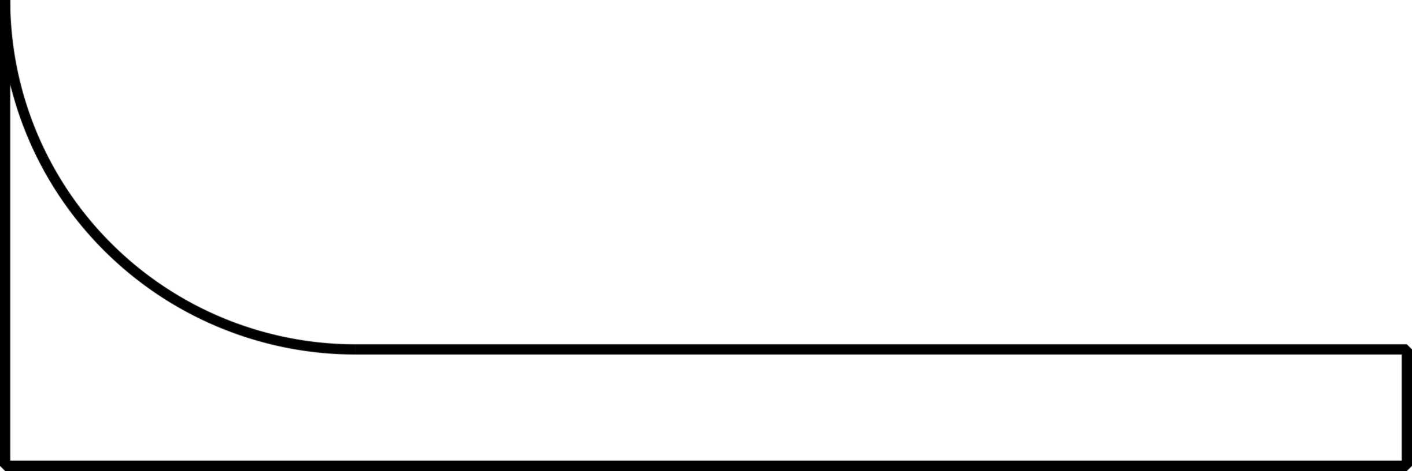
A
B
C
D
E
F
4%
2%
5%
Age Related Failures – 11%
Non-Age Related Failures – 89%
7%
14%
68%

Failure patterns A, B, and C are age / usage related, and are caused by degradation caused by age, by exposure to their operating environment, or their usage. Failure characteristics can include: wear / deterioration; lubrication failures; dirt; falling apart (welds breaking, fasteners loosening); and failures caused by human error that reduces the capability of the asset.
Failure patterns D and E are predominantly random, and are caused by events that damage the assets such they can no longer sustain the stress at the time the event occurs, or weaken it to the point that it may fail later with a high level of stress it might otherwise be able to withstand. As they can occur at any time and their probability is the same throughout their lifetime, the failures are considered random. There is no way we can predict when the events may occur and cause the failure.
Failure pattern F is predominantly infant mortality, followed by a period of a reduced level of random failures. With infant mortality failures, the item is more likely to fail when first put into service, or be returned to service after work is performed on it (installation, maintenance, turnaround, overhauls). Infant mortality failures can be caused by: design errors, or bad or marginal design; poor installation; poor assets or substandard parts; and poor workmanship. Many of those causes noted above are project related (e.g. design, quality of assets, installation) issues (see December 2010 newsletter for general discussion), and some are issues related to performing maintenance. For the maintenance related issues, skilled, knowledgeable, and motivated technicians are a big part of the answer for workmanship. For the issue with parts, what about the phone call you get from Purchasing telling you that he “…has sourced the identical part at a big discount…”, but of course, the part is not identical… If the part is of substandard quality and not suitable for use, then it likely to fail more frequently introducing an infant mortality failure when installed, and any savings in the individual part price can be easily surpassed by: the greater number of parts required; increased labour costs caused by more frequent repairs; and the biggest cost is typically related to the asset being out of service (e.g. reduced output, expedited shipping, customer service issues, product / service quality issues, etc.).
As assets and systems get more complex, the probability of errors and resulting infant mortality failures can increase.

Impact on Asset Management, Maintenance, and Reliability
To address the different failure patterns, different approaches are required.

Preventive Maintenance (PM)
For age / usage related failures, with sufficient information on failure history, it may be possible to determine when the asset is likely to fail and then take it out of service before it fails. On a routine scheduled basis determined by age or usage, it can then be replaced with a new or rebuilt unit, or the original rebuilt or repaired, and returned to service.
The consequence of failure related to the unscheduled downtime are managed, including:
- reducing secondary damage;
- reducing long duration of the unscheduled outage and resulting reduction in output, especially processes with long ramp up or shutdown periods (i.e. improved Availability);
- impact to customer service (missed deliveries, quality of product or service impact);
- reduce safety or environmental consequence related to unscheduled failures; and
- reduce operating costs related to wasted materials or excessive energy usage.
To be most effective, the work needs to be performed just prior to it failing, and for age / usage related failures just before the rapid increase in conditional probability of failure in patterns A and B, and when the conditional probability of pattern C reaches a point where it is likely to fail. With failure history, MTBF (Mean Time Between Failure) can be calculated, but preventive maintenance is not performed at the time of MTBF, as by definition, half of failures would have occurred (assuming symmetrical historical failure curve). The correct timing would be MTBF, minus the half of the time of the failure distribution curve, to address variability.
As there is no increase in conditional probability of failure in patterns D and E, preventive maintenance is not effective, and a waste of money and resources, and in performing the intrusive preventive maintenance work, might introduce a failure (i.e. pattern F failure). Where pattern F is the dominant failure pattern, then the intrusive preventive maintenance work is not just a waste of money and resources, it potentially resets the infant mortality “clock” and can make it more unreliable.
In preventive maintenance, age or usage is used as a substitute for condition, and to reduce failure consequences, often a conservative approach is taken, especially if there is limited failure history, and the asset taken out of service prematurely before it reaches the end of its lifetime.
If condition could be effectively measured and in a cost-effective manner, then that needs to be considered in its place, as discussed next.

Predictive Maintenance / Condition Based Maintenance
For failures with age / usage failures and with periods of random failures, in may be possible to on a routine scheduled basis, monitor the condition of the asset. Then based upon condition, either continue to let it operate, if the condition is good, or plan and schedule a corrective repair before it fails. The corrective work might be the same or similar to the work that might be performed if scheduled in preventive maintenance, but it is scheduled based upon condition, not upon age or usage. The benefit of reduced failure consequences is the same as preventive maintenance listed above.
The frequency of the routine scheduled monitoring is dependent upon how much warning (i.e. PF Interval) the condition monitoring method provides. Condition monitoring can be performed through the use of specialized technology or equipment (e.g. vibration analysis systems, infrared thermography, oil analysis, etc.), through monitoring process parameters (e.g. motor current, pressure, flow, temperature, etc.), or through human senses (sight, sound, touch, smell), as it does not need to be expensive or complex, if the method provides sufficient lead time to avoid the consequences.
However, for the infant mortality period, there is no condition that can be monitored to warn of the failure with sufficient lead time prior to failure, as it fails immediately or shortly after being put into service, or put back into service. To address infant mortality, one time changes may provide the required solution, our next discussion topic.

One Time Changes / Re-Design
One time changes can take the form of re-design of the asset itself to make it more reliable (e.g. more robust design, better materials, improve quality of build / installation), or reduce the consequence of failure (e.g. reduce safety or environmental consequences, reduce downtime by improving diagnostics or easier to repair, redundancy).
Also the processes, procedures, and tasks to operate and maintain the asset can be revised to improve reliability or reduce the failure consequences, as well. To reduce the potential for human error related to not performing the changed activities correctly, they should be documented and be issued as SOP (Standard Operating Procedures) for operators, or job plans for maintainers. This is especially important for events that can cause random failures, and the documentation is critical for procedures that are not often performed (e.g. start-up procedures or emergency shutdown of continuous processes).
And the capability of those who operate and maintenance the assets can be improved through training, and thus improve reliability and reduce failure consequences.
There still remains the situation where the loss of a protective function caused by the failure is not evident under normal circumstances, our next discussion topic.

Failure Finding Tasks / Functional Tests
As protective devices / systems may operate only under abnormal conditions, it may not be evident (i.e. hidden failure) if they are in a failed state under normal circumstances. With failures having age / usage or random failure patterns where it is not technically feasible AND worth doing a predictive maintenance or preventive maintenance task to effectively address a hidden failure, then it may be possible to perform a failure finding task that will provide a tolerable / effective manner of managing the circumstances.

Run-To Failure
For those situations where the consequences are financial only, and a suitable predictive or preventive (or failure finding task for hidden failure) cannot be found, then it might be appropriate to decide to let it run to failure.
Failure patterns are useful in determining what might not be appropriate tasks given the nature of the failure…

Upcoming
Please advise me, if there are other topics on asset management, maintenance, reliability, or project management issues that would you would find of interest.
The 2017 version of PEMAC’s (Plant Engineering and Maintenance Association of Canada) MainTrain will be held in Saskatoon. For more information, see: www.MainTrain.ca.

Contact Us
To provide feedback on this newsletter, including comments on past articles, ideas for future articles, add names for other interested colleagues or friends (please copy them with your request), or to remove your name from distribution of this newsletter, please e-mail me at len@asset-management-solutions.com.
Please feel free to contact us to discuss any of your physical asset management requirements. For more information on how we can help you, please contact me directly. See our web site at: http://www.asset-management-solutions.com for other information on Asset Management Solutions, including asset management issues and solutions.
Copyright 2003 - 2017 © Leonard G. Middleton – Asset Management Solutions

