Copies of current and past newsletters can be found at: http://www.asset-management-solutions.com/newsletters.htm
Newsletter for May 2018
I appreciate receiving your comments on this newsletter and any suggestions for future topics. If there is someone you know who would be interested in receiving this newsletter, please feel free to forward the newsletters to them, or forward their e-mail address to me and I will include them in the distribution of future newsletters. If you wish to remove your name from distribution of this newsletter, please respond via e-mail. Please see “Contact Us” at bottom for e-mail address for feedback, comments and removal from distribution.
To keep this newsletter relatively short, this is intended to be a broad overview of issues for maintenance, reliability, and asset management, rather than a comprehensive discussion of the topic.
This month’s newsletter is from Ben Stevens. Ben can be reached at: StevensB@kingston.net
If you have any questions or topics you would like to have us discuss, please send them to me.
Further changes have resulted in me again providing management consulting services under the Asset Management Solutions banner. I will continue to collaborate with Ben to continue to share our knowledge and insights through these newsletters. We have a number of readers worldwide and feel we have been providing a useful service to those who might otherwise want or need the alternate insights provided.
Note to Canadian subscribers: With the change in anti-spam legislation, we are required to ask you to opt-in to confirm your wish to continue to receive our newsletter. However, as we have never tracked the Canadian subscribers from our international ones, I am uncertain as to how to identify the Canadian subscribers who did not opt-in. As noted in the first paragraph above of all the newsletters, please contact us to have your name removed from the distribution list. We have honoured all past requests for removal and will continue to do so in the future.

Maintenance Projects – Is there a Pay-off? Part 2
In the April 2018 newsletter, we finished off by defining Return on Investment (ROI) as:
ROI = Revenue – Cost
Investment
This formula is one of the basic financial KPI’s that are used to determine whether an investment is “worthwhile”. In this newsletter, I want to concentrate on breaking out the components of Revenue and Cost. to see how Maintenance and Reliability contribute to the core KPI. In the next newsletter, we’ll look at the third element – Investment – at consider the implications of the ROI measurements as they affect decision-making in M&R.
First of all, ROI is extremely flexible – applicable to any time period (Month, Year, Project Duration, Equipment Life Cycle, etc.), and any subset of a business (equipment, product line, plant, department, division whole business). Second, as we’ll see later, everything we do changes the actual ROI – it bounces around like a ping-pong ball, all the time. That’s a fact of life – get used to it!
Here’s a simplified diagram of how the components of ROI are linked together:
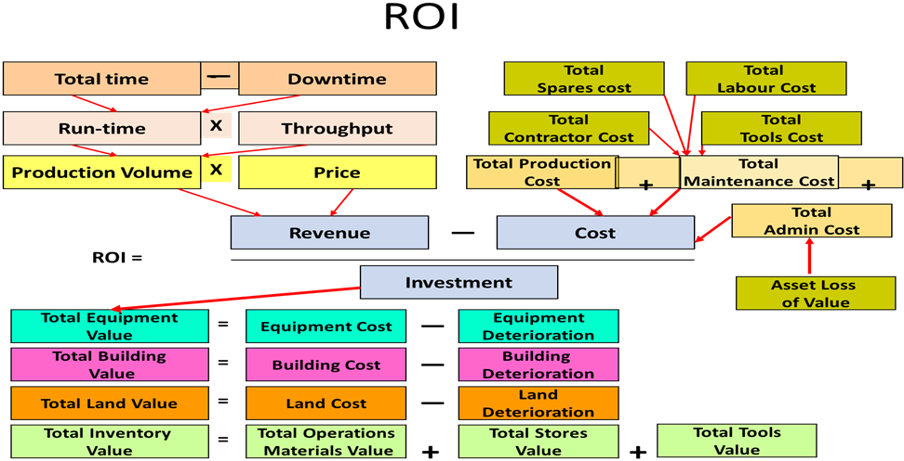
Let’s look at each of the core components in turn:

Revenue Components:
- Total Time – this represent total available hours = 8760 (one of those numbers that needs to be seared into the brain of any Maintenance analyst!) = 365 days x 24 hours.
- Downtime – combines all of those hours during which the equipment is not running – scheduled and unscheduled, planned and unplanned.
- Total Time minus Downtime gives us Run-time – the actual number of hours that the equipment is running.
- Throughput shows the volume of output per hour and will be an average for the period.
- Run-Time x Throughput gives us our output Volume.
- The Price charged to the customer x Volume provides us with our total Revenue.

Issues with the Revenue Components
- A couple of things to watch for which can throw out the accuracy of the Total Time calculation for a year: 24 x 7 x 52 gives us 8736, and of course every fourth year, it’s 366 x 24 = 8784.
- Total Time will be adjusted to accommodate whatever period your ROI covers – whether it is a month, a year or a life-time.
- In measuring our ROI calculation, we don’t care why there is Downtime, we just use the numbers. Of course, when we conclude that the ROI is too low, then we will analyse the reasons, and excessive downtime may well be a contributor.
- Notice that Quality or Scrap does not directly enter into the calculation. Scrap is eliminated from Volume by deducting it from average Throughput. Quality is accounted for by adjusting the Price.
- Managing the ROI calculation when the equipment does not generate direct revenue – this is tricky. What we really want to use instead of revenue is benefit or contribution provided by the asset. Examples (be creative!):
  - A service truck – extra revenue generated by the assets that it services due to less downtime, shorter travel time
  - New Service building – improved uptime from shorter MTTR for assets that are serviced faster in the new building; less wait time, more efficient repair time.
  - Any service asset - Ignore the revenue impact and concentrate on the cost reduction impact. If it’s a replacement, then measure the cost advantage of the new asset.
  - Calculate the total business’ ratio of revenue to asset value and use that as a substitute number (you’ll find the base numbers in the financial statements on the website.) Example – total equipment/assets $1.1m; total revenue $1.5M. Assumed new asset revenue = 1.5/1.1 x asset cost
  - In non-revenue-generating organizations, focus on evaluating the net benefit from the asset in terms of impact on the more effective delivery of services, extra value of services delivered, customer satisfaction etc.

Cost Components
- Focus on two key aspects of cost:
  - The cost of operating the asset – materials consumed, manpower costs, contractors, spares, energy and utilities etc.
  - If it is a replacement asset, then look for improvements and efficiencies in the operating costs compared to the asset being replaced.
- Production or Operating Cost – include here the cost of running the asset to produce the output volume – energy and utilities, operators, raw materials
- Maintenance Costs – these are the costs that we are most familiar with and represent our direct Maintenance budget for the asset – labour, contractors, tools, spares
- Admin costs include all the other costs that will be incurred by the asset during it’s operation. Notice that we have (in the diagram) separated out the Asset’s loss of value. We’ll address that later under the comments on depreciation.

Issues with the Cost Components
- Organizations track their costs in many different ways. It’s best to familiarize yourself with how your business does it before you start. Your friends in Accounting will help here. In particular:
  - How are shared costs attributed to an asset – electricity and water for example, space costs
  - Next there are the costs incurred by the M&R department that are distributed among different projects (“direct overheads”) – shared management costs, training, building costs.
  - What about “indirect overheads – HR, Procurement, Finance, IT etc. Do these have to be included in your Project ROI calculation?
- For the Labour costs, find out whether the company’s standard is to use an overall average, or different pay rates for different skills; whether the base pay rate is used or whether it is marked up to account for benefits, vacations
- Similarly, for the spare parts – should you use the vendor costs or add in your own organization’s overhead costs for the warehousing, shipping and handling. Notice that “Spares” appears twice in the ROI calculation. As a component of Costs, we include only those spares that have been charged to a work order or job card. For a comment on Spares as an investment, look for the comment in the Investment section in the next newsletter.
- Also, for free issue spares and consumables, we need to understand the accounting rules. They may be charged directly via the work order as consumed, or they may be included in a Maintenance direct overhead charge. Or sometimes, they are not charged at all!
- For tools, be aware of the policy for charging the costs of special tools, shared tools (among a restricted list of assets), common use tools, cost of calibration etc.
- For the Asset Loss of Value item, sometimes this is included as an Admin charge, and sometimes as an Operations or a Production cost. Ask Accounting! More on this later.
This covers two of the three core components of ROI. To keep our newsletter to a reasonable length, let’s pause here and deal with Investment next time. Please bear in mind a couple of items:
- Different organizations have different rules; I have long argued that every M&R department should have an accounting person working with them – with all the options we have to deal with, you can see why. Please make sure you clarify your organization’s rules. If you don’t then you can expect your Project to be rejected!
- We’ve skimmed fairly lightly over the topics so far, and this is not easy stuff.
If you have questions, please email me at stevensb@kingston.net.

Upcoming
Please advise me, if there are other topics on maintenance management, project management, or physical asset management issues that would you would find of interest.
The 2018 version of PEMAC’s (Plant Engineering and Maintenance Association of Canada) MainTrain will be held in Ottawa. For more information, see: www.MainTrain.ca.

Contact Us
To provide feedback on this newsletter, including comments on past articles, ideas for future articles, add names for other interested colleagues or friends (please copy them with your request), or to remove your name from distribution of this newsletter, please e-mail me at len@asset-management-solutions.com.
Please feel free to contact us to discuss any of your physical asset management issues. See our web site at: http://www.asset-management-solutions.com for other information and past Asset Management Solutions newsletters.
Copyright 2003 - 2018 © Leonard G. Middleton – Asset Management Solutions

